CSC 241 Homework 1
Marcus Schaefer
3. (Hello World Program, 12pt)
Here is my program:
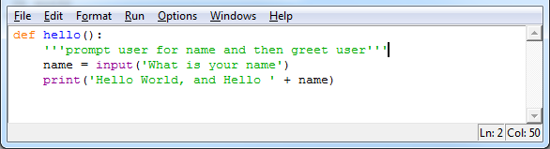
And here is the output, I couldn’t get a space between “name” and the actual name.
